Accessing STAAR 3-8 and EOC Scores using Skyward Family Access
Información en español aquí

Results should be available in your child’s Texas Assessment account
on the following timeline:
Assessment | Date Available from TEA
STAAR, Grades 3-8 | Friday, June 24, 2022
STAAR End-of-Course (EOC) | Thursday, June 16, 2022
TELPAS | Monday, May 27, 2022
Summer EOC | Friday, August 5, 2022

- Log in to Skyward using a desktop computer or laptop device. These directions will not work with the Skyward App on your cell phone.

- Click on the “District Links” link, located at the top left of the home screen.

- Click on the “TEA Assessment” link.

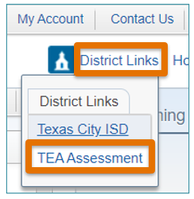

- A new window will open, and you will automatically be logged into your child’s Texas Assessment account. You can view a video, download the STAAR report card, or click a specific test to learn more about your child’s results.

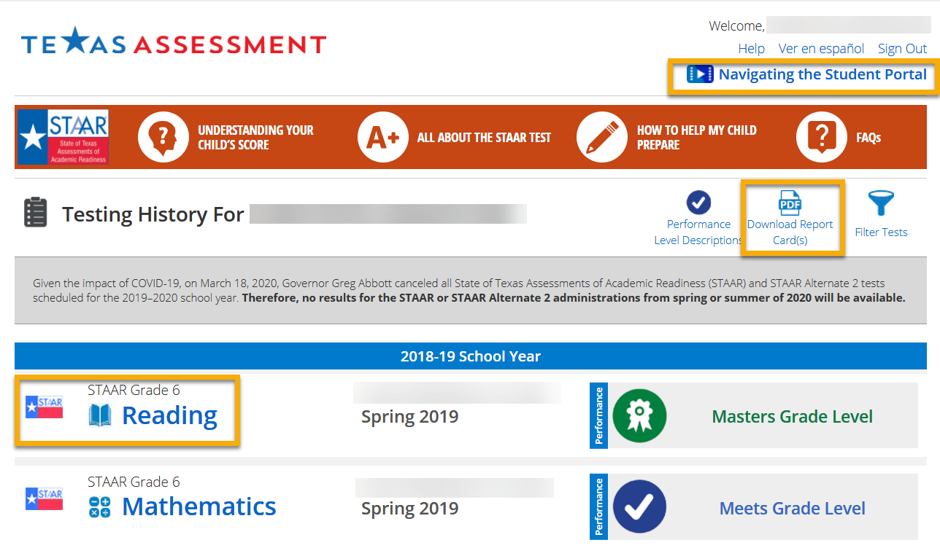

- Families with more than one child will be able to view each child’s results by clicking on the child’s name.

- If your child’s results are not available, you will see the following message.
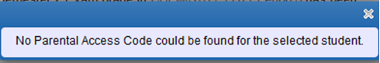

If you need assistance, please submit this form between June 20 – 30, 2022. The form will be closed for summer and will reopen on July 18, 2022.

