Texas City Independent School District
Calvin Vincent Early Childhood Center
Head Start Program

Annual Report 2019-2020

Texas City Independent School District
Calvin Vincent Head Start Program
1805 13th Avenue North
Texas City, Texas 77590
(409) 916 – 0512

Table of Contents

Mission Statement 3

Head Start Staff 3

Director’s Greeting 4

Philosophy 4

TCISD Beliefs 5

History 6

Head Start Service Areas 7

Explanation of Expenditures 8

Proposed Budget 8
Children and Families Served 8

Enrollment Profile 2019-2020 9

Federal Review Results 9

Financial Audit Results 9

Child Health and Development 10

Parent Involvement 10

Preparing Students for Kindergarten 11

Child Outcomes 12

Mission Statement
The mission of the Texas City ISD Head Start Program is to recruit and equip eligible Head Start families with the tools and resources necessary to promote and support them to become responsible and productive citizens in society. The program recognizes the need to increase school readiness, in a cooperative effort with home and community, through the provision of services designed to enhance the development of the whole child.
Head Start Staff
Aldridge, Sandra | Family Advocate Assistant
Alfaro, Kristi | Head Start Teacher Assistant 4 Year Olds
Brooks, Jeanie | Parent Involvement Coordinator
Butler, Linda | Head Start Teacher Assistant 4 year olds
Castro, Theresa | Head Start Teacher 3 year olds
Clay, Shandra | Head Start Teacher Assistant 4 year olds
Dillon, Michelle | Lead Family Advocate
Dillon, Trennie | Head Start Teacher Assistant 3 year olds
Dunkel, Amanda | Head Start Teacher 4 Year Olds
Gongora, Maria | Bilingual Head Start Teacher Assistant 4 year olds
Hernandez, Melissa | Secretary/ ERSEA/Student Data
Jaramillo, Martha | Head Start Teacher 3 year olds
Kelly, Kristen | Health Manager/ Nurse
Kushner, Adriana | Head Start Teacher 4 year olds
Lindsey, Julie | Head Start Teacher 4 year olds
Miranda, Andrea | Head Start Teacher Assistant 3 year olds
Proctor, Haley | Head Start Teacher Assistant 4 year olds
Robeson, Amy | Head Start Teacher 4 year olds
Schoppe, Debbi | Head Start Teacher 4 year olds
Tiscornia, Lourdes | Head Start Teacher Bilingual 4 Year Olds
Troconis, Rebeca | School Coordinator/ Administrator
Unger, Susan | Principal/ Head Start Director
Whitten, Terri | Head Start Teacher Assistant 4 year olds

A message from Susan Unger, Program Principal and Director

On behalf of the TCISD Calvin Vincent Head Start Program, I am pleased to present you with the 2019-2020 Annual Report. This report is in accordance with the Head Start Act of 2007 and has been developed to provide information regarding program operations, expenditures, and activities from Fiscal Year 2020 to the community we serve.

The teachers and staff of Calvin Vincent Early Childhood Center believe that education is the key to success and we continue to strive to ensure excellence in our programming and instruction. We are proud of the services we offer and welcome the opportunity to share our practices and program information with the community we serve. We ascertain the District’s guiding principle that “Together we Succeed”; therefore, we commit to prepare our students for their future by building relationships, making learning relevant and rigorous, and developing each student’s unique talents and skills.
Philosophy
The Calvin Vincent Early Childhood Center Staff believes that it is important to meet the needs of low income families and their children, whereas growth and development opportunities are provided to empower families to strive for self-sufficiency and life-long success. It is also our belief that through effective collaboration between family, school and the community, Head Start families will be offered a range of comprehensive services that will improve the lives of children and families over a long period of time.

Texas City Independent School District Together We Succeed

Our Beliefs
- Every decision should be based upon what is best for students.
- All stakeholders should be treated with respect.
- Cultural diversity should be embraced.
- High expectations should be maintained for all employees and students.
- District employees should take time to know and understand students and colleagues.
- High quality instruction should be delivered in an engaging manner.
- All students should have opportunities to explore and develop their unique traits.
- Each Texas City ISD graduate should be college and/or career ready.
- All TCISD graduation pathways are worthy and deserving of respect.
- Implementation of quality research-based professional development will improve student learning.
- All district personnel have a moral obligation to create, maintain and support a learning environment that is academically, emotionally and physically safe.
- Shared leadership and collaboration are essential for our success
Our Mission
We will prepare our students to reach their full potential and excel in their chosen paths.

History of Calvin Vincent Head Start Program

TCISD Head Start opened its doors to provide an eight-week summer program to 60 children in June 1965, the inception of Head Start Programs across the country. The federal grant funds were channeled through Galveston County Community Action Council (GCCAC) to establish Texas City as a delegate agency to serve preschool children in Texas City School District, which was composed of 19.3 square miles.

In 1970, Head Start became a nine-month program and offered limited transportation services to and from school. Over a period of 20 years, the program relocated to several school district campuses, increased the funded enrollment from 60 to 130, converged with the District’s pre-kindergarten program, purchased buses and became a delegate agency of Hitchcock Independent School District. During the 30th anniversary of Head Start in 1995, Texas City ISD Board of Trustees proclaimed the program to be named “Calvin Vincent” Head Start, honoring the 30-year Head Start Director, Calvin Vincent.

In 1997, TCISD Head Start received a federal grant award to support the renovation/addition project at the Heights Elementary campus to accommodate Head Start and pre-kindergarten students. The project was completed in September 1998, and the program relocated to the Heights campus, servicing approximately 200 students. Placement on the elementary campus allowed the students excellent transitional activities, access to the gym, cafeteria, library and opportunities for parent participation in the PTO (Parent and Teacher Organization). The program offered a morning and an afternoon session – three and a half hours each, to three and four-year-old students at the Heights campus.

The Office of Head Start began its move from indefinite project periods to five-year periods in January 2012. This change required Texas City ISD Head Start Program, a delegate agency and Hitchcock ISD, the grantee, to re-compete for a five-year grant project. The proposal in the re-competition grant included some major changes to the current program operation. The proposed changes described a request to become grantee, increase funding, increase the funded enrollment, change the service option from half day to full day, and relocate to a District’s newly renovated larger campus. An overall improvement to the quality of services was proposed and approved by the Office of Head Start in July 2013.

The new five-year grant awarded Texas City ISD grantee status, increased funding, additional staff, and a funded enrollment of 154 children for a full day classroom setting. In August 2013, the Calvin Vincent Head Start Program re-located to the District’s renovated building located at the campus of the old high school. The building was renovated specifically to accommodate the growth of the District’s Pre-K/Head Start Program and was named “Calvin Vincent Early Childhood Center.” The Head Start Program continues to have a strong collaboration with the District’s pre-kindergarten program, maximizing resources, staff and services to over 250 children and families in Texas City School District. Services include education, health, nutrition, social services, parenting/fatherhood involvement, disability, transportation, and mental health counseling.

TCISD Calvin Vincent Head Start Service Area
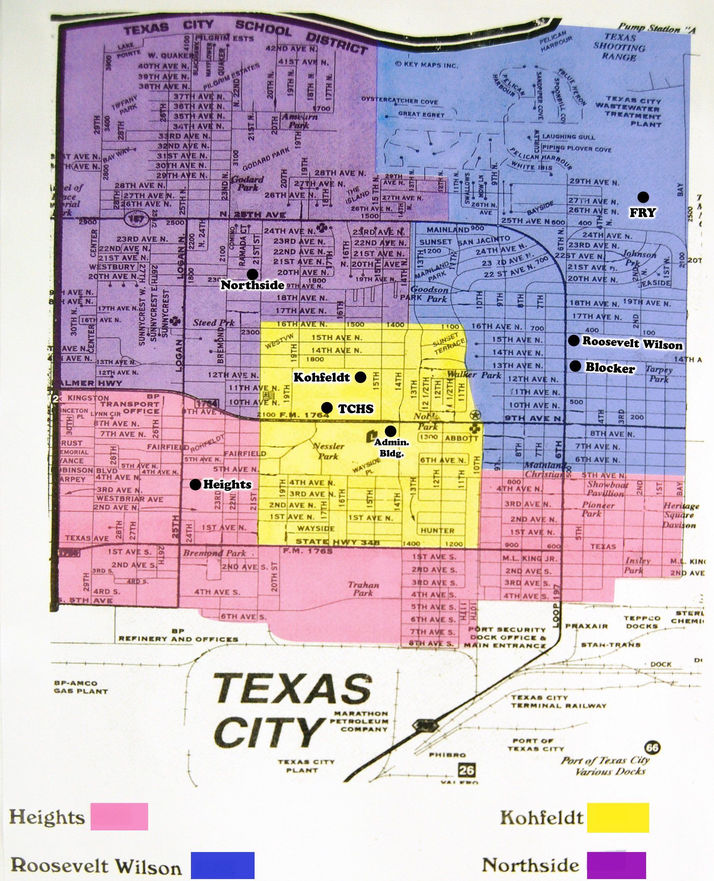

Explanation of Expenditures

Explanation of Expenditures

Data Control Codes | September 1, 2019 – August 31, 2020 | Fund 205  Head Start
5900 | Total Revenue | $1,081,835
 | Expenditures
0011 | Instruction | $678,676
0013 | Curriculum and Instructional Staff Development | $81,219
0023 | School Leadership | $102,700
0033 | Health Services | $25,631
0034 | Student Transportation | $12,033
0051 | Plant Maintenance & Operations | 0
0052 | Security and Monitoring Services | $32,224
0061 | Community Services | $149,352
6030 | Total Expenditures | $1,081,835
Proposed Budget

Object Class Categories | Federal | Non-Federal | Total
Personnel | $988,237 | $197,671 | $1,185,908
Fringe Benefits | $29,557 | 0 | $29,557
Travel | 0 | 0 | 0
Supplies | $153,005 | 0 | $153,005
Contractual | $70,042 | 0 | $70,042
Other | $89,239 | $134,849 | $224,088
TOTAL DIRECT CHARGES | $1,330,080 | $332,520 | $1,662,600
Children and families served

During fiscal year 2020, the Texas City ISD Calvin Vincent Head Start Program was funded to service 154 children and families with the provision of a grant award of $1,330,080. The average monthly enrollment was 154, and the average daily attendance (ADA) was 92.3%. There were eight full day classes.
2019 – 2020 Enrollment Profile

Student Age | Three Year Olds | 33
 | Four Year Olds | 140
Attendance | Average Daily Attendance | 92.3%
Ethnicity | Hispanic or Latino Origin | 93
 | Non-Hispanic or Non-Latino Origin | 80
Race | American Indian or Alaska Native | 0
 | Asian | 0
 | African American | 62
 | White | 89
 | Biracial/Multi-racial | 22
Primary Language Spoken | English | 144
 | Spanish | 29
 | Other (East Asian Languages) | 0
Family Income | Number of Families Income Eligible | 99
 | Number of Families Over Income | 1

Results from the most recent federal reviews

During the 2016-2017 school year we received notice that each of the five previous federal reviews showed that there were no findings, areas of non-compliance, or deficiencies found within the Calvin Vincent Early Childhood Center Program. Therefore, we were automatically qualified to apply for another five-year grant. We are currently in year two of that new grant.
Financial audit results

STATE SUMMARY OF AUDIT RESULTS
YEAR ENDING AUGUST 31, 2020
Were there any disclosures in the Annual Financial Report and/or other sources of information concerning default on bonded indebtedness obligation? | No
Did the district receive a clean audit? – Was there an unqualified opinion in the Annual Financial Report? | Yes
Did the Annual Financial Report disclose any instances of material weaknesses in internal controls? | No
Was there any disclosure in the Annual Financial Report of material noncompliance? | No

Child Health and Development

Through partnerships between Galveston County medical and dental providers, students received medical screenings and preventive dental care at a reduced cost. This partnership established medical and dental homes for parents and resulted in all students receiving all required medical and dental exams.
Parent Involvement

The Head Start Program believes that it is important to assist parents in achieving their goals while always understanding that parents are their child’s first and most important educators. Therefore, the Head Start Program develops partnerships with each family upon enrollment. Through parental surveys, an annual calendar of parent involvement activities and trainings are determined. The parent activity calendar is designed to provide meetings that will offer training experiences and activities to support and enhance the parental role. The Head Start Program encourages effective parent involvement through training programs, participation as volunteers, and elections to the policy committee. A listing of activities presented to parents for the 2019-2020 school year follows:

August: Parent Orientation, Meet the Teacher, and School Readiness Committee Meeting

September: Discipline Workshop

October: Parent Conference Day, Fire Station Field Trip, Trick or Treat Night, Pumpkin Patch Visit

November: Read Me A Story Campaign and Charlie Brown Thanksgiving Feast

December: A Visit from Motorcycle Santa and the Christmas Celebration

January: Desserts with Dads

February: Family Literacy Night

March: Virtual only due to COVID-19

April: Virtual only due to COVID-19

May: Virtual only due to COVID-19

Preparing Students for Kindergarten

Calvin Vincent Early Childhood Center, in collaboration with parents, Policy Council, and district professionals, supported the approval of the Frog Street Press curriculum for the 2019-2020 school year. The curriculum is designed to meet the goals and objectives outlined in the Head Start Child Development and Learning Framework as well as the Texas Pre-Kindergarten Guidelines. It is a child-centered, developmentally appropriate, comprehensive blueprint for the planning and designing of meaningful lessons for students. An emphasis is placed on achieving school readiness through relevant, meaningful activities in all eleven domains of the Child Development and Learning Framework. The staff is experienced, knowledgeable and well-trained on implementing the Frog Street Press curriculum during the school year.

As a component of Frog Street Curriculum, Conscious Discipline is adopted as the campus management plan. Classrooms were supplied with the tools necessary to carry out the focus of regulating behavior and emotions, becoming confident, independent thinkers and learners, and encouraging creativity and exploration.

A wide range of instructional strategies are incorporated into each classroom on a daily basis: whole group, small group, individual. Children are allowed to initiate many of their own activities. However, there are also opportunities for teacher-led lessons. This variety allows for all children to be successful learners, including our English Language Learners and students with disabilities. It is responsive to the variety of cultures and family styles that are present in our community. Teachers have been trained in differentiating the instruction for their students so that all children can learn in the ways that they learn best. Our curriculum identifies goals in all areas of development, social, emotional, cognitive, and physical. Teachers utilize a wide variety of instructional strategies that respect the developmental stages of preschool children which include:

- Literacy – vocabulary, language development, phonological awareness, letters, words, print, comprehension, books and other written text
- Mathematics – numbers, patterns and relationships, geometry and spatial awareness, measurement, and data collection, and organization
- Science – the physical properties of objects, living things, and the earth and environment
- Social Studies – how people live, work, get along with others, shape and are shaped by their surroundings
- Creative Arts – dance, music, dramatic play, drawing and painting
- Technology – tools and their basic operations and uses
- Approaches to Learning – observing and exploring; problem solving; and connecting, organizing, communicating, and representing information

Calvin Vincent Head Start ensures children are successful learners by checking their progress at three different times during the school year, using CLI Engage, an objectively based assessment, to obtain child outcomes. In addition to this assessment, students are assessed via a locally designed report card three times each year and with the Brigance screening instrument two times each year. The CLI Engage assessment is accessible online and is sponsored by Texas School Ready. It encompasses greater than 50 indicators in each of the Head Start objectives/dimensions and generates student assessment data in the following areas: Language and Literacy, Cognition/Mathematics, Social-Emotional, Approaches to Learning, and Perceptual, Motor, and Physical.
Head Start Student Outcomes

The graph below indicates progress made by TCISD Head Start students from the fall of 2019 to the winter of 2019 in all assessed domains. The third wave of assessments were canceled due to school closure for COVID-19. The graph illustrates the overall agency results for 154 children assessed from the fall to the spring. The analysis of ongoing child assessment data reviewed the following findings:
- Significant growth in the objectives of all Domains
- The Head Start Program has a significant effect on student readiness for kindergarten.

Student Outcomes
CLI Engage Assessment
End of Year Campus Comparison Data
2019-2020

The teachers observe, guide, and assess children to identify their developmental progress. When the content of the curriculum is taught with children’s developmental stages in mind, children are more likely to be successful learners. The teachers collect facts, analyze and evaluate each individual child’s development. The information will be used to plan for individual and small group instruction. The teacher will implement individual student plans and an ongoing monitoring system to observe and document the progress of each child.

Ongoing assessment is the key to planning relevant, meaningful classroom activities. Child progress is communicated to parents, Policy Council, and the Governing Board regularly. Our students demonstrated great percentages of growth in all dimensions. We are very pleased with the average growth demonstrated by all students and are confident that they are well prepared for kindergarten.

Texas City Independent School District does not discriminate against any student, employee, volunteer or applicant because of race, color, religion, gender, national origin, age, marital or veteran status or disability. Assistance for special needs as defined by the Americans with Disabilities Act may be requested by persons accessing TCISD programs and services by calling (409) 916-0106 at least 3 days before the aid or service is needed. Inquiries regarding this policy should be directed to Mr. Marcus Higgs, Director of Human Resources, at the TCISD Administration Building, 1700 Ninth Avenue North, Texas City, TX 77590 or call (409) 916-0107.

